**Software Requirements**

**Specification**

for

**<Event Management System>**

Version 1.0 approved

Prepared by <Tejas Sangle>

<Dr. D. Y. Patil Institute of Management & Research>

<03-11-2023>

**Table of Contents**

**Table of Contents……………………………………………………………………………….ii**

**Revision History……………………………………………………….………………………..ii**

**1. Introduction………………………………………………………………………………….1**

1.1 Purpose…………………………………………………………..………………………1

1.2 Document Conventions………………………………………….………………………1

1.3 Intended Audience and Reading Suggestions..………………….………………………1

1.4 Product Scope………………..……………………………….…………………………1

1.5 References………………………………………………….……………………………1

**2. Overall Description…………………………………………………………………………2**

2.1 Product Perspective……………………………………………………………………..2

2.2 Product Functions……………………………………………………………………….2

2.3 User Classes and Characteristics………………………………………………………..2

2.4 Operating Environment…………………………………………………………………2

2.5 Design and Implementation Constraints………………………………………………..2

2.6 User Documentation…………………………………………………………………….2

2.7 Assumptions and Dependencies…………………………………………………………2

**3. External Interface Requirements………………………………………………………….3**

3.1 User Interfaces…………………………………………………………………………..3

3.2 Hardware Interfaces……………………………………………………………………..3

3.3 Software Interfaces………………………………………………………………………3

3.4 Communication Interfaces………………………………………………………………3

**4. System Features…………………………………………………………………………….4**

4.1 System Features 1……………………………………………………………………….4

**5. Other Nonfunctional Requirements……………………………………………………….5**

5.1 Performance Requirements……………………………………………………………..5

5.2 Safety Requirements……………………………………………………………………5

5.3 Security Requirements………………………………………………………………….5

5.4 Software Quality Attributes…………………………………………………………….5

5.5 Business Rules………………………………………………………………………….5

**6. Other Requirements……………………………………………………………………….5**

**Appendix A: Glossary**

**Appendix B: Analysis Models**

**Appendix A: To Be Determined List**

**1.Introduction:**

Event Management is the process of analyzing, planning, marketing, producing and evaluating an event. It is a different way of promoting a product, service or idea. If an event is managed efficiently and effectively, it can be used as a very powerful promotional tool to launch or market a product or service.

**1.1 Purpose:**

Software requirements specification (SRS) is a document that describes what the software will do and how it will be expected to perform. It also describes the functionality the product needs to fulfill all stakeholders (business, users) needs.

This System Requirement Specification (SRS) aims to provide the readers and users information about the system and its functions and specifications.SRS describes the data, functional and behavioral requirements of the software.

This software is designed to manage the events in the party. This will take the users requirements for about party events According to the user requirement it estimate how much cost are coming in the whole event .The main purpose of it provide services related to event to the user in very optimize cost.

**1.2 Component Object Model:**

An interface standard for software components used to enable inter-process communication and dynamic object creation.

* Database(DB):

A system intended to organize, store, and retrieve large amounts of data easily; a repository of information.

* Events:

A social gathering or activity.

The font for text will be Times new roman (12) for headers it will be Times new roman (15).

**1.3 Intended Audience and reading suggestions**

The intended readers of this SRS are developers, event heads, managing staffs and the event

organizers. Reading the general descriptions before proceeding to the specific requirements would help the readers easily understand the background behind the functions of the system.

**1.4 Scope**

The proposed system provides an automated system for the Users who want to book various event with ease.

* User Management System
* Employee Management System
* Venue Management System
* Catering Management System
* Report Problems

**1.5 References**

[1]. L. McCathie and K. Michael, “Is it the End of Barcodes in Supply Chain Management?”, Proceedings of the

Collaborative Electronic Commerce Technology and Research Conference LatAm, 2005.

[2]. M.Mahalakshmi, S.Gomathi and, S.Krithika, “Event Management System”, 2016.

[3]. Sandeep Misal, Segar Jadhav, Tushar Jore , Archana Ugale ,”Event Management System .

[4].Roozbeh Derakhshan, Maria E. Orlowska and Xue Li, “RFID Data Management: Challenges and Opportunities”, IEEE International Conference on RFID, 2007.

**2.The Overall Description:**

Sometimes, certain events do not get the recognition that they should. The main method of communication for these events is via a poster or mouth to mouth. It is getting very clear that these methods of communication are becoming more and more dated. Recently, twitter and Facebook have been shown to be more receptive in regards to communication via a Client and the attendees. To follow this trend, this system is being implemented to facilitate communication between the clients and the potential event-goers. As well, as provide up to the minute updates and information about the event.

**2.1 Product Perspective**

The software will be a new independent product, that it, it is not a component of another program. It is intended for the administration of the management and other concerned users.

The staff members and the manager/supervisor aside from the developers can only access this information. All the forms used in the product follows a clear and logical structure. Errors will be minimized with drop-down buttons and command buttons to eliminate the excessive use of text input. Management of data includes searching, adding, modifying and deleting. The product specified will be developed for web application .

**2.2 Product Functions**

Event management system is a program designed to assist managers, event organizers, firms, and other users whose line of business deals with events management to manage their

participants’ data in an orderly manner. It shall perform the following functions:

• Protect the database of the firm by requiring a correct and registered username and password.

• Make data organization easier by classifying participants according to sub-types of personal events.

• Facilitate a systematic process of entering, organizing, retrieving, modifying and deleting data from the database without the need to go the database itself.

• Add new client information easily.

• Provide an option for users to update information.

• Delete existing client information.

• Create new events.

• Provide an easy function where you can go back one form whenever necessary.

• Present a list of participant codes representing existing clients.

• Add new supplier contacts with which future collaboration is expected.

• Display client information in an organized manner for easy understandability.

• Display payment terms of participant including the total event fee, amounts paid by the participants and the balance.

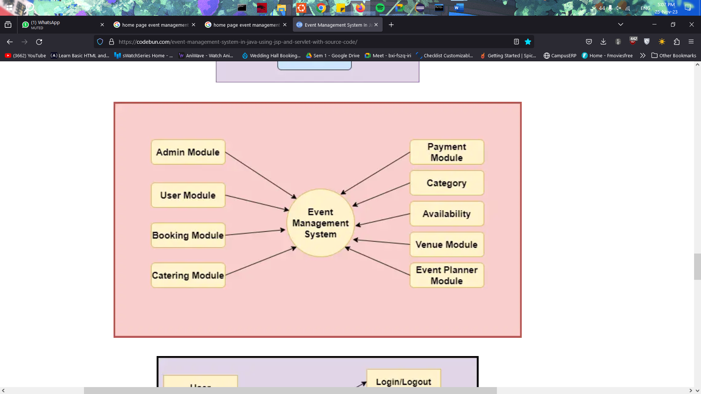

**2.3 User Classes and Characteristics**

The users of the system will be Customers and professionals. They will be having the knowledge regarding how to book an event and which destination or which services they require and a basic knowhow of using the internet and computers.

**2.4 Operating Environment**

The software will operate on an internet based application where the minimum configuration should be 20GB hard disk, Ram minimum 1GB, processor i3.

**2.5 Design and Implementation Constraints**

The users should have all the support neede to run a web based application. All the system must be compatible with internet applications. All the needs of users will be considered for development of the product.

**2.6 User Documentation**

User manual, online help will be provided with proper user training.

**2.7 Assumptions and Dependencies**

The online management system will work on an web based application and work with association with other softwares like online venue booking system, online catering booking system.

**3. External Interface Requirements:**

**3.1 User Interfaces**

Log in page:

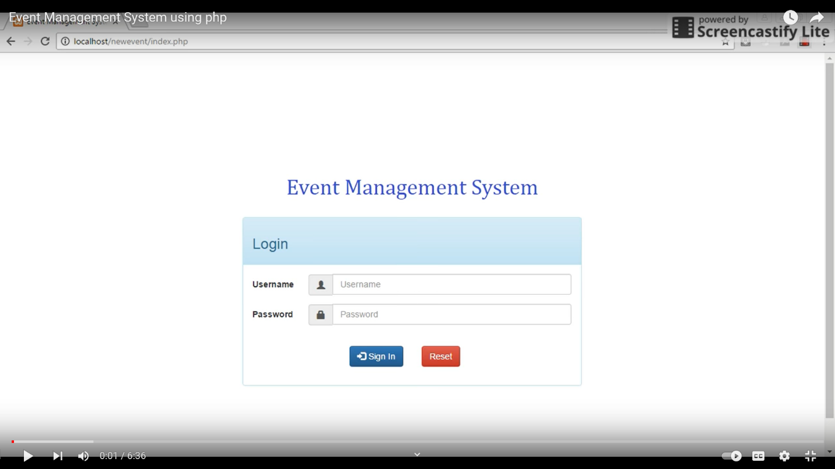

Home page:

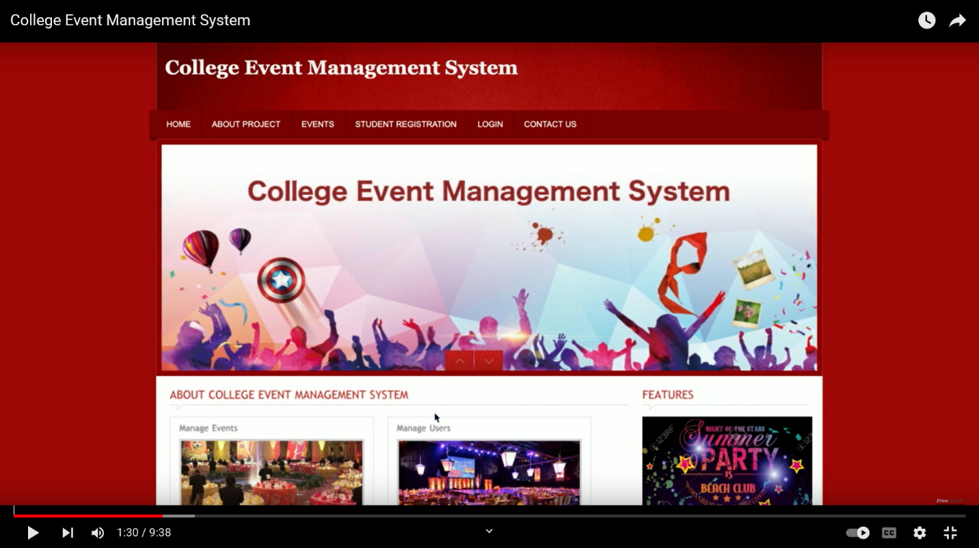

**3.2 Hardware Interfaces**

The Internet will be used for collecting data from users and also for calculating the number of participants and events. Various routers, firewalls will be used for security mechanisms.

**3.3 Software Interfaces**

The data will be shared approx various software, operating systems.

**3.4 Communication Interfaces**

The system must freely connect with world wide web so it must have consistency with the relevant protocol and it should be compatible with all browsers

**4. System Features**

**4.1 System Features**

The following functionalities of the product will be shown using use case:

* User Management System
* Event Management System
* Billing Management System
* Billing Management System
* Report Problems

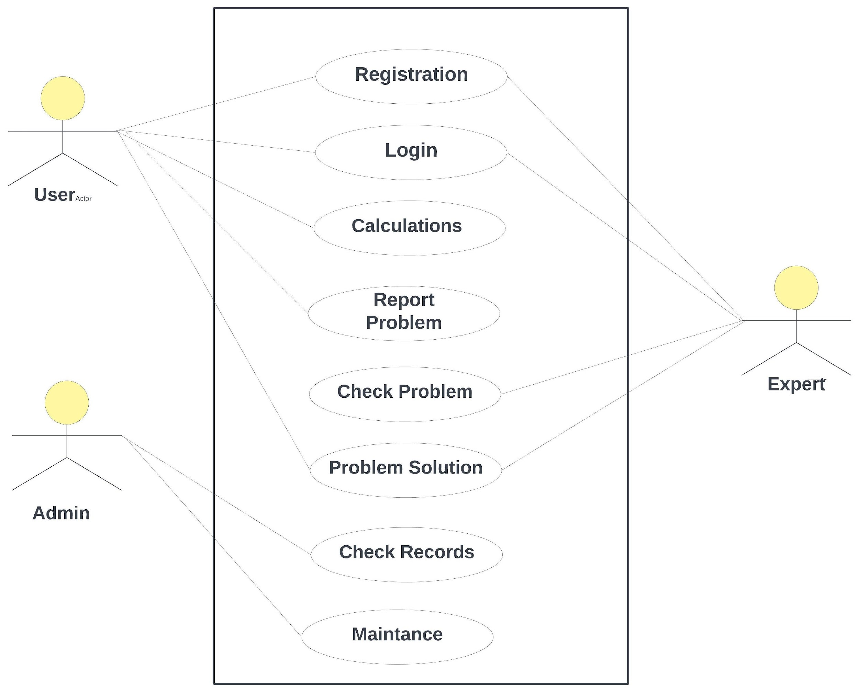

**5. Other Nonfunctional Requirements**

**5.1 Performance Requirements**

The response time should be fast i.e. data retrieval should be done fast.

**5.2 Safety Requirements**

Proper backup facility should be there to ensure safety against possible loss damage or harm that could be done due to natural calamities and cyber crime.

**5.3 Security Requirements**

The usage of online Event management system advisory System will be restricted only to registered users so proper measures and licensing agreements has to be made.

**5.4 Software Quality Attributes**

The software should be adaptable, available, correct, flexible, interoperable, maintainable, portable, reliable, reusable, robust, testable and usable.

**5.5 Business Rules**

All the rules for design and development for the software will be under the jurisdiction of Department of event managers.

**6. Other Requirements**

NA